**SWE645 – HW3: Containerize survey form and setup Kubernetes cluster using Rancher**

**Team Member: Aniket Pandey, Siddhanth Kalyanpur, Tanush Singh**

**Step 1: Write POST and GET api using Spring Tool Suite and connect to SQL**

* Following are the two APIs

* + GET https://{baseurl}/api/v1.0/surveys
  + POST https://{baseurl}/api/v1.0/surveys

Body

{

"firstName": "John",

"lastName": "Doe",

"email": "john.doe@mail.com",

"address": "9155 Walnut St",

"city": "Bentonville",

"state": "AR",

"zip": "22031",

"telephone": "8188884114",

"dateOfSurvey": "04-28-2022",

"recommendation": "Very Likely",

"interest": "Friends",

"likings": "Students"

}

* The Data Model looks like the following fields

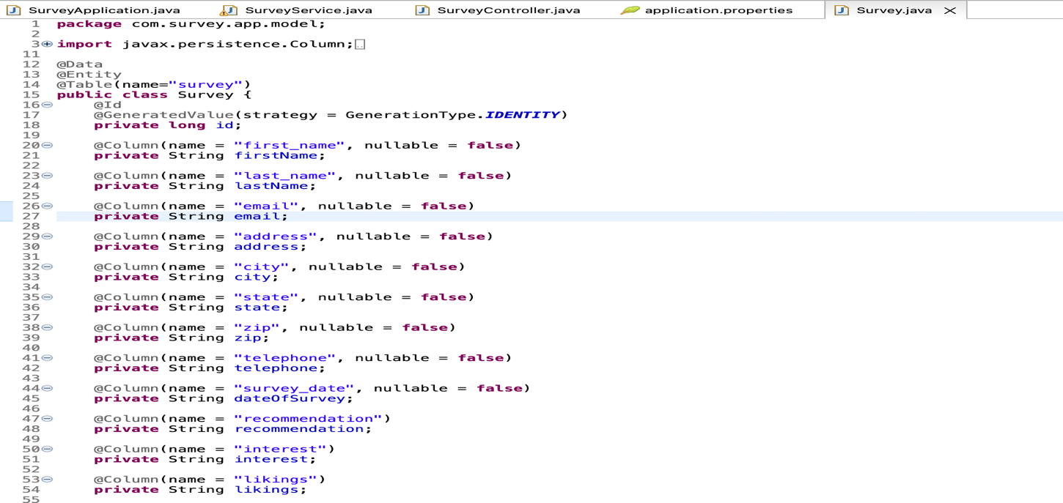

* Write the API and create MySQL database using AWS RDS
* Copy the database endpoint, port number, username and password
* Using JDBC connect to database and write the following lines in application.properties

* The api can be tested using Postman
* GET API

* POST API

* The Database record can be viewed using MySQLWorkbench

* Now right click on the pom.xml file and build the JAR packaging. The JAR file will be present inside target folder by default.

**Step 2: Build Docker image and containerize survey api using Docker**

* Write Dockerfile as below

* Build docker image with the below command. My Dockerfile is inside infra folder and therefore I’ve specified path as infra/Dockerfile. As a standard practice all the infrastructure setup related files should be kept inside infra folder for easy segregation.

docker build -f infra/Dockerfile --tag survey-api:amd64-v1.0 .

* Tag the docker image and push it on dockerhub using the below command

docker tag survey-api:amd64-v1.0 aniket414/survey-api:amd64-v1.0

docker push aniket414/survey-api:amd64-v1.0

**Step 3: Create two EC2 instance, one for deployment and the other for Rancher setup**

* Select the Ubuntu ami from AWS marketplace and create one instances for Rancher and select Amazon Linux 2 ami and create instance for deployment of rest api.
* Allow inbound traffic using security group from following ports

**Step 4: Setup Rancher on one of the instance**

* SSH into the instance using pem file

ssh -i key-value.pem ubuntu@public-dns

* Install docker after updating

sudo apt-get update

sudo apt install docker.io

* Install Rancher using the following command

sudo docker run --privileged -d --restart=unless-stopped -p 80:80 -p 443:443 rancher/rancher

* After some time open instance public dns which will display Rancher login page where we’ll setup username and password
* Login inside and click on create cluster
* Choose custom option from the list of available of available choices and click next
* Enter the cluster name and leave everything as default and click on next
* In the next section select control plane, etcd, and worker and copy the command generated

**Step 5: Setting up another instance for orchestration**

* SSH into the instance using pem file

ssh -i key-value.pem ec2-user@public-dns

* Install docker after updating

sudo yum update

sudo yum install docker

sudo service docker start

* Run the above copied command and after some time go to the Rancher page and you should see cluster provisioning has started.

* Condition of the cluster is active and healthy

**Step 6: Deploy the docker image on cluster on setup three pods running at all time**

* Enter the cluster just created on Rancher and click on Deployment under the Workload section. Alternatively you can also copy the kubeconfig file and if you have kubectl setup done on your local then paste the kubeconfig file content in .kube/config and you can easily access the cluster and deployment using kubectl from your local.
* Enter the replica set as mentioned in assignment i.e. 3
* Enter the docker image uri
* Setup NodePort as a service

* Click on done and you should see your pods coming up.

* You can also verify the status from local using kubectl command
* Following are the screenshot of service, node, deployment, and pods

